logo, yazı tipi, metin, grafik içeren bir resim

Açıklama otomatik olarak oluşturuldu

**UNDERSTANDING USERS PROJECT – SEN 4105**

i.) Project Team:

Sudenaz Öğdem

Selin Çeçen

Mehmet Girişken

Ümmü Gülsüm Ergin

Mehmet Hisar

Ediz Özdil

ii.) User Interviews: In this section, we'll discuss our process and findings from the user interviews conducted to gather requirements for our mobile reuse app.

iii.) Persona: Here, we'll present a persona created based on the insights gathered from our user interviews. This persona will represent our target user and guide our design process.

iv.) Problem and Activity Scenarios: This section will discuss a problem scenario that describes current user practice and an activity scenario that represents an ideal user experience in relation to the Design Problem.

v.) Figma Design - Prototype: Here, we'll showcase our initial design for the mobile reuse app. We will provide a visual walk-through of the user interface and functionalities using the Figma digital prototyping tool.

vi.) Heuristic Evaluation: In this section, we'll undertake a Collaborative Heuristic Evaluation (CHE) of our digital prototype. We'll document the usability problems we identify and provide the mean severity ratings for each issue.

vii.) Re-design Prototype: Based on the findings from the heuristic evaluation, we'll revise our prototype. We'll document the changes made to address the identified usability issues.

viii.) Appendix: Any additional supporting information or resources related to our project will be included in this section.

**INTERVIEWS**

1- Gender

Answer: Female

2- Age

Answer: 22

3- What field of study are you in?

Answer: Studying Psychology at Medipol University, 3rd-year student.

4- What types of second-hand items do you usually look for?

Answer: I mostly use second-hand apps for clothes and bags. I can find barely used and beautiful products at affordable prices.

5- What do you pay the most attention to when looking at second-hand items?

Answer: First of all, it's very important that the item has been used cleanly and minimally. I look at what the seller has sold before. The reviews the seller receives provide a good reference for whether the product will be the same as in the photos.

6- If you were to sell second-hand items on an internet site, what would you consider to be the most important factor?

Answer: The commission fee the platform will take is very important because I wouldn't want to give them half the price of the product I'm selling. The less they take, the more money I keep. Also,

the popularity of the platform I'm going to sell on is important because it means I'll reach more people.

7- Have you ever downloaded or used apps? If so, can you tell us about your experience?

Answer: I have used many second-hand apps like Dolap, Letgo, and Sahibinden. I haven't had any problems using these apps before. But of course, it's very important for users to pay attention to sellers and reviews. I make an effort to not buy items with bad reviews. I can find both affordable and beautiful products. As most sellers here are small and individual, they don't have agreements with shipping companies, and we often have to pay for shipping, which isn't pleasant. Overall, using these apps is easy as their interfaces are designed for everyone to understand.

8- What do you think of the interface of second-hand apps? What catches your attention visually?

Answer: When I first enter the app, the colors and the options section catch my attention. Letgo is designed with white and pink, but white is more dominant. I would have preferred more prominent colors. On the homepage, it offers suggestions based on random sellers, not by topic headings. It would have been more organized and convenient to see them in specific categories like Trendyol. There is a search bar at the top, followed by extensive filtering options, making it easier to find the type of product you're looking for.

9- What is the second-hand app that you use the most, and how has its ease of use affected your life?

Answer: The second-hand app I use the most is Dolap. Having such apps is actually very useful for both buyers and sellers. Buyers can find what they need at an affordable price, and sellers can benefit from their unused products. The app is very easy to understand and use for both buyers and sellers. You can find or sell what you're looking for in just a few minutes.



1- Gender

Answer: Male

2- Age

Answer: 21

3- What field of study are you in?

Answer: Political Science and International Relations at Medipol University, 3rd-year student.

4- What types of second-hand items do you usually look for?

Answer: I mostly look for second-hand cars and hobby-related products.

5- What do you pay the most attention to when looking at second-hand items?

Answer: I mostly pay attention to the price; it should be reasonable compared to other similar products. Second, I look at the usage duration and condition, as this will indicate how long I can use the item without problems and whether it's worth purchasing.

6- If you were to sell second-hand items on an internet site, what would you consider to be the most important factor?

Answer: I would pay the most attention to the popularity of the app, as more people using it means I would have a wider range of options and a higher likelihood of finding affordable products. High user preference can indirectly prove the app's reliability.

7- Have you ever downloaded or used apps? If so, can you tell us about your experience?

Answer: I have used many of these apps (sahibinden.com, Letgo, arabam.com, Facebook Marketplace). If I need to give information about the one I use the most, it would be sahibinden.com. Among these apps, sahibinden.com is where I can easily find what I'm looking for. When I search, it shows the most relevant results.

8- What do you think of the interface of second-hand apps? What catches your attention visually?

Answer: I think second-hand app interfaces should be user-friendly, and the leading sites in the industry are usually the ones where you can easily find what you're looking for and have a wide variety. I prefer simplicity; when I enter the site, I don't want extra confusing information and images. The only visually appealing section for me would be where the products are displayed, and this could be designed in a more pleasant and less straining manner.

9- What is the second-hand app that you use the most, and how has its ease of use affected your life?

Answer: The app I use the most is sahibinden.com. The ease of finding what I'm looking for saves me time. The wide variety allows me to find more profitable products, and the familiar interface prevents me from feeling like a stranger on the site. Besides, I think the services it offers are beneficial for both buyers and sellers. It helps prevent misunderstandings or scams, which increases my trust in the app.

1- Gender

Answer:Female

2- Age

Answer: 23 years old

3- What field of study are you in?

Answer:Interior design student

4- What types of second-hand items do you usually look for?

Answer: I mostly look for antique and decorative items when searching for second-hand items.

5- What do you pay most attention to when purchasing second-hand items?

Answer: When buying second-hand items, I highly value the item's durability, how old it is, and how much it has been worn. Ultimately, it is very important how usable the product is since we are reusing it.

6- If you were to sell second-hand items on an online platform, what would be most important to you?

Answer: It is very important that the platform where I sell my items ensures the safety of my sales, the products I sell, and my payment.

7- Have you ever downloaded or used apps? If so, can you tell us about your experience?

Answer: Dolap and Hepsiburada.

8- What do you think of the interface of second-hand apps? What catches your attention visually?

Answer: The filtering feature should be highly visible in the application.

9- What is the second-hand app that you use the most, and how has its ease of use affected your life?

Answer: Pinterest. It allows me to easily find inspiration and sample projects for my projects with just a few keywords.

**4)**

1- Gender

Answer: Female

2- Age

Answer: 20 years old

3- What field of study are you in?

Answer: Culinary art student

4- What types of second-hand items do you usually look for?

Answer: I usually look for clothes and shoes when searching for second-hand items.

5- What do you pay the most attention to when looking at second-hand items?

Answer: When buying second-hand items, I give great importance to the item's quality, condition, and how much it has been used. Ultimately, the item's utility is important since we are reusing it.

6- If you were to sell second-hand items on an internet site, what would you consider to be the most important factor?

Answer: Ensuring the safety of my sales, my products, and my payment is very important when selling items online.

7- Have you ever downloaded or used apps? If so, can you tell us about your experience?

Answer: I have never used any second-hand applications before.

8- What do you think of the interface of second-hand apps? What catches your attention visually?

Answer: It is important to clearly see the product in the application's interface and for the interface to be visually appealing and easy to navigate.

9- What is the second-hand app that you use the most, and how has its ease of use affected your life?

Answer: I mostly use Instagram to find inspiration and cooking ideas. Its ease of use has allowed me to quickly access a wide range of food-related content.

**5)**

1- Gender

Answer: Female

2- Age

Answer: 21 years old

3- What field of study are you in?

Answer: Management Engineer

4- What types of second-hand items do you usually look for?

Answer: My family was very busy with the car buying and selling business, so I was enthusiastic and got into this business. I love looking at second-hand shops when buying and selling cars. Sometimes I find myself on those sites even if I don't buy them.

5- What do you pay the most attention to when looking at second-hand items?

Answer: One of the things I care about most is the opportunity to bargain. I always prefer to buy cars by bargaining instead of buying them at raw prices. Also, the price is a big factor. Damage and duration of use are also extremely important and necessary details for me. I take care to choose the ones that have a short lifespan. I also choose apps that show them.

6- If you were to sell second-hand items on an internet site, what would you consider to be the most important factor?

Answer: I prefer platforms where the highest commission is low and reliable. I spend a lot of money on cars anyway. In this way, when these platforms increase their commission fees, I switch to different platforms. Of course, I choose well-known reliable platforms, not insecure platforms because they are cheap.

7- Have you ever downloaded or used apps? If so, can you tell us about your experience?

Answer: Arabam.com is the first app I use the most. They help me a lot when buying and selling my cars. The interface is very nice and useful and I don't have any problems in terms of usage. Support lines are very strong. I also use Wardrops for my clothes. No commissions, no shipping charges, and all my money comes to me. It's just that the interface is so slow and poor quality that it makes me sad.

8- What do you think of the interface of second-hand apps? What catches your attention visually?

Answer: The interface of HepsiBurada is very bad, it is one of the last applications I will use. No matter how much I love Amazon's discounts, I can never use it because its design and interface was pretty bad. One of my favorite interfaces would be my Arabam.com and the other one would be the Dolap, probably both very useful and comfortable.

9- What is the second-hand app that you use the most, and how has its ease of use affected your life?

Answer: Sahibinden.com and Arabam.com might be the two I use the most. I use it even when I'm not buying and selling cars. Gardrops and Dolap also offer great opportunities for me to evaluate my clothes. Although I do not like the design of the Gardrops, the possibilities it provides make me happy.

**6)**

1- Gender

Answer: Female

2- Age

Answer: 22 years old

3- What field of study are you in?

Answer: Industrial Engineer

4- What types of second-hand items do you usually look for?

Answer: Since I am a student and I am constantly changing houses, I am looking for household goods. It is possible to find both suitable and quality products among many options.

5- What do you pay the most attention to when looking at second-hand items?

Answer: Price is one of the most important factors because a product that I will buy second-hand should be at least cheaper than normal ones. Therefore, the most important option is the price, and then whether there is damage, or the duration of use can be very important to me. If it is damaged, it is important that it decreases in terms of price.

6- If you were to sell second-hand items on an internet site, what would you consider to be the most important factor?

Answer: The popularity of the platform is the most important because if the visibility of my products decreases, no one will buy them. On the popular platform, my products are displayed more, and I get more requests and offers.

7- Have you ever downloaded or used apps? If so, can you tell us about your experience?

Answer: I mostly use owner and letgo. Buying and selling household goods proceeds the fastest from there. I also use the closet app to sell my clothes and small kitchen utensils. I make money and beautify my home.

8- What do you think of the interface of second-hand apps? What catches your attention visually?

Answer: If I think of it as shopping apps, the interfaces of N11 and HepsiBurada are very messy and ugly. It never attracts users, but rather pushes them. Poor quality and slow. The interface I like the most is Trendyol because everything is at hand and looks interesting. Even the fonts they use for the concepts are enough to encourage shopping.

9- What is the second-hand app that you use the most, and how has its ease of use affected your life?

Answer: I used Letgo the most. I still use it. I'm currently selling coffee machines and I'm getting offers every day because it's a popular and up-to-date platform. If I ever change house again, I'll sell most of my stuff there.

**7)**

1- Gender

Answer: Male

2- Age

Answer: 21 years old

3- What field of study are you in?

Answer: Software Engineer

4- What types of second-hand items do you usually look for?

Answer: Car. I think the best thing to look at in the used market is a car. If I'm going to buy a car, it's the second hand one that fits my budget best and it's pretty fun to look at.

5- What do you pay the most attention to when looking at second-hand items?

Answer: The quality of the product is the most important to me. I also take into account the popularity of the app, the seller's rating, comment and attitude. Not without looking at the price and duration of use. If I'm going to rank for the car, it's quality, time of use, price, popularity of the app. But I would like to add that after seeing the car physically, I don't get hung up on the application that much.

6- If you were to sell second-hand items on an internet site, what would you consider to be the most important factor?

Answer: The facilities it provides are definitely number one for me. I'll put the commission in second place. If I sell second hand, I pay attention to the commission that the platform will receive because I will sell a car. In my opinion, there should not be an exorbitant price, and of course I prefer the application where the commission is low. Then I care about popularity. It is very important for the sale to be fast and easy.

7- Have you ever downloaded or used apps? If so, can you tell us about your experience?

Answer: I used sahibinden.com, letgo, gitgidiyor, Hepsiburada applications. I only used sahibinden.com as second hand. As far as I know, they do not take commission from the owner and I mentioned that I care about this. User-friendly and easy to use, easy to understand and can be used by everyone. Considering the number of users, I find its speed good. Being able to look at the map on real estate is a very nice feature. You can also filter the information you want while looking for a used car.

8- What do you think of the interface of second-hand apps? What catches your attention visually?

Answer: It has a very good interface from its owner. I think it is comfortable and user friendly. That's why I find it pretty clear.

9- What is the second-hand app that you use the most, and how has its ease of use affected your life?

Answer: I use sahibinden.com a lot. Even if I am not going to buy something, I go to the site and follow what the 2nd hand market is in to find out the value of that thing.

**8)**

1- Gender

Answer: Female

2- Age

Answer: 21 years old

3- What field of study are you in?

Answer: Physical therapy and rehabilitation

4- What types of second-hand items do you usually look for?

Answer: Antiques and books. If I'm buying the book secondhand, I want it to be old because I want to see the notes of someone who has read it before. So my goal is to experience that nostalgia. In antiques, I would like to share the story and feelings of people who have used it before. That's the whole point, to be able to empathize.

5- What do you pay the most attention to when looking at second-hand items?

Answer: The reliability of the application is very, very important. I look at the seller's style because no matter how good the product is for me, if the seller's style is not what I expected, I will not buy it. In addition, it is very valuable that the application is useful and that I can find answers to every question I seek. Also, the easy interface of the application provides a more comfortable shopping environment for me.

6- If you were to sell second-hand items on an internet site, what would you consider to be the most important factor?

Answer: I mostly look at the possibilities and reliability of the application, I would like to sell on a quality platform. Besides popularity, functionality is also very important because some applications have names but may not be useful. Of course, as a seller, I want my work to be seen.

7- Have you ever downloaded or used apps? If so, can you tell us about your experience?

Answer: I have used Dolap, sahibinden.com, letgo applications. I have looked for products from Letgo, I have also sold products from Cabinet. Communication is easy on Letgo. Reliability is also very important in Dolap, users with high scores buy their products.

8- What do you think of the interface of second-hand apps? What catches your attention visually?

Answer: The cabinet seemed complicated to me, but still useful. Because the product has all kinds of details, but this also makes it complicated, I think. The things that catch my attention visually are the designs, page layout and logos. It shouldn't be a lot of text. That's why I find the owner's interface unprofessional.

9- What is the second-hand app that you use the most, and how has its ease of use affected your life?

Answer: I use Letgo a lot. I usually sell household items. Like a chair or a table. I don't like having too much stuff. I'm trying to be minimalist.

**9)**

1- Gender

Answer: Female

2- Age

Answer: 19

3- What field of study are you in?

Answer: Statistics

4- What types of second-hand items do you usually look for?

Answer: I only look at clothes, shoes, and jewelry.

5- What do you pay the most attention to when looking at second-hand items?

Answer: I prefer products with labels, so it is more important to me that they are unused and more suitable than normal.

6- If you were to sell second-hand items on an internet site, what would you consider to be the most important factor?

Answer: I pay attention to the commission that the platform will take. Because sometimes it happens so much that is not beneficial.

7- Have you ever downloaded or used apps? If so, can you tell us about your experience?

Answer: I downloaded apps sahibinden.com, Letgo and Dolap but only made Dolap purchases. The commission rate he received was a little high.

8- What do you think of the interface of second-hand apps? What catches your attention visually?

Answer: I can easily find and buy the product I'm looking for, just like the apps we shop for. I have no difficulty in the payment part, the directions are very descriptive.

9- What is the second-hand app that you use the most, and how has its ease of use affected your life?

Answer: Since X is easy to use, I can easily sell my unused items.

**10)**

1- Gender

Answer: Female

2- Age

Answer: 21 years old.

3- What field of study are you in?

Answer: Dentistry

4- What types of second-hand items do you usually look for?

Answer: I generally look at clothes and shoes, I also look at very rare books.

5- What do you pay the most attention to when looking at second-hand items?

Answer: First, I look at how long the product has been used, then I compare prices.

6- If you were to sell second-hand items on an internet site, what would you consider to be the most important factor?

Answer: Definitely the reliability of the platform, I do not want to have problems later.

7- Have you ever downloaded or used apps? If so, can you tell us about your experience?

Answer: Dolap is my most used second-hand app. I think it is very easy to use, there are products in a wide variety and price range. I also tried using Letgo, but since Dolap seemed simpler, I deleted it without doing any shopping.

8- What do you think of the interface of second-hand apps? What catches your attention visually?

Answer: I have never evaluated this subject, but now that I look at it, I realize that I can progress very easily in the application. Products are divided into categories so I can find what I'm looking for very easily.

9- What is the second-hand app that you use the most, and how has its ease of use affected your life?

Answer: As I just said, thanks to X, I can dispose of my unused clothes and find new clothes at a very affordable price. The easy use within the application allows me to do all these without difficulty.

**11)**

1- Gender

Answer: Female

2- Age

Answer: 22 years old

3- What field of study are you in?

Answer: Studying Medicine in Turkey

4- What types of second-hand items do you usually look for?

Answer: I mainly look for books, clothes and sometimes electronic items like laptops or phones.

5- What do you pay the most attention to when looking at second-hand items?

Answer: I check the condition of the item first, and then consider the price. For books, I check if there are any markings or notes.

6- If you were to sell second-hand items on an internet site, what would you consider to be the most important factor?

Answer: The platform's reliability and reputation are most important to me. I also look for a low commission fee.

7- Have you ever downloaded or used apps? If so, can you tell us about your experience?

Answer: I have used Dolap and Sahibinden.com. Both have been positive experiences, but I find Dolap easier to navigate.

8- What do you think of the interface of second-hand apps? What catches your attention visually?

Answer: I prefer an interface that's easy to navigate, with clear categories and search functions. It makes finding what I want easier.

9- What is the second-hand app that you use the most, and how has its ease of use affected your life?

Answer: It's made selling my old items and finding second-hand items I need much simpler and faster.

**12)**

1- Gender

Answer: Male

2- Age

Answer: 22 years old.

3- What field of study are you in?

Answer: Engineerin

4- What types of second-hand items do you usually look for?

Answer: I often look for electronic gadgets, computer parts, and sometimes cars.

5- What do you pay the most attention to when looking at second-hand items?

Answer: I look at the condition of the item, how long it's been used, and the price.

6- If you were to sell second-hand items on an internet site, what would you consider to be the most important factor?

Answer: I consider the popularity of the platform, the commission they take, and how easy it is to use.

7- Have you ever downloaded or used apps? If so, can you tell us about your experience?

Answer: I have used Sahibinden.com and Letgo. I prefer Sahibinden.com as it has a wider range of items.

8- What do you think of the interface of second-hand apps? What catches your attention visually?

Answer: A simple and clear interface is best. It helps me find what I need quickly.

9- What is the second-hand app that you use the most, and how has its ease of use affected your life?

Answer: It's made buying and selling second-hand items convenient and hassle-free.

Persona

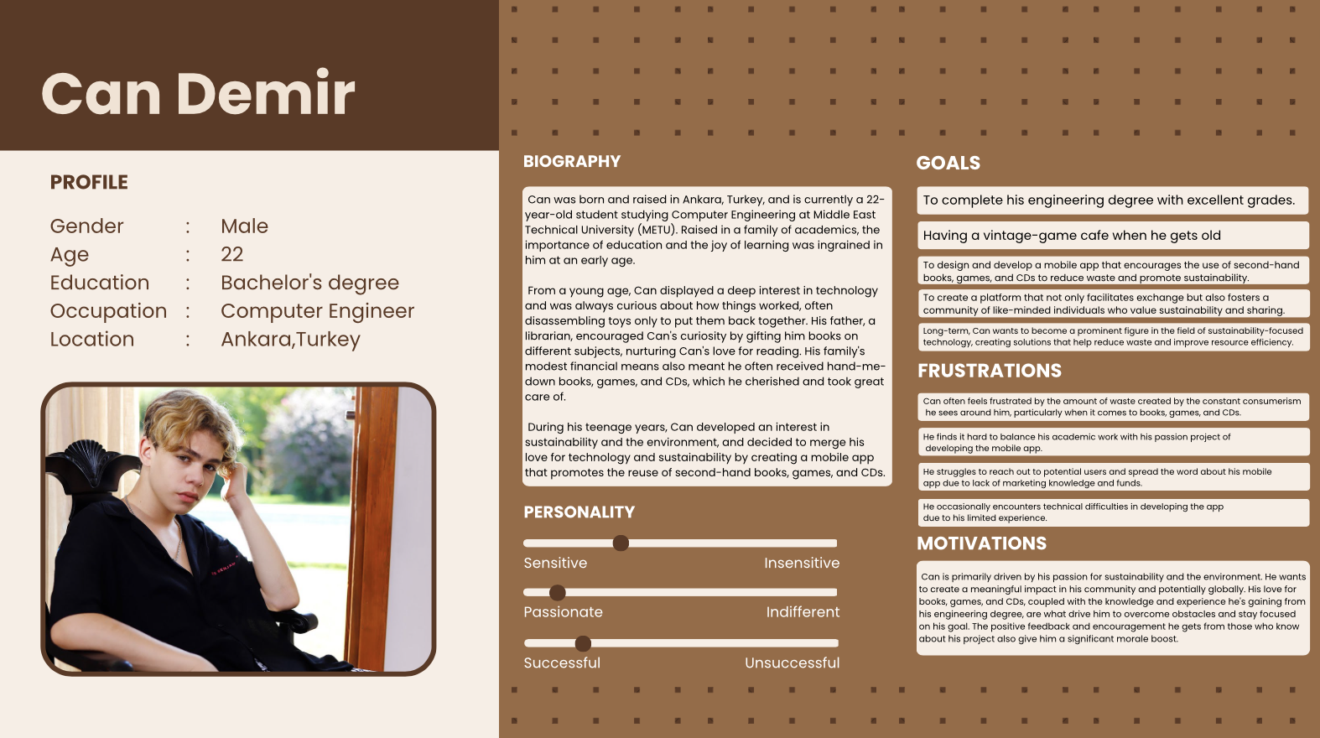

Problem scenario :

Can Demir, a 22-year-old METU Computer Engineering student, has a month till his girlfriend's birthday. His partner, an avid collector of vintage books and games, recently voiced her wants during a casual talk over a cup of tea. She stated how she'd want to get her hands on a first edition copy of Jane Austen's "Pride and Prejudice," an elusive item for any antique book collector. During the same conversation, she reminisced about playing "Rangarok".

Though Can does not share her love for the specific game, he is excited at the prospect of gifting her these products since he knows how much joy they will bring her. However, finding these presents is a difficult task. The initial edition of "Pride and Prejudice" and the game are pricey and difficult to locate in regular stores or on e-commerce platforms due to its scarcity and historical value. They are often sold in specialized collector's stores or at auction, where prices can be exorbitant.

Can is a university student on a limited budget. He doesn't have the luxury of spending a lot of money on these gifts, but he also doesn't want to skimp on the quality or originality of the products. This complicates his situation even more. Furthermore, being a big proponent of sustainability, Can is opposed to purchasing new products that may contribute to environmental harm. He passionately believes in the principle of reuse and prefers to acquire used products wherever possible.

Can is in a difficult circumstance as a result of this situation. He must find a way to obtain these old artifacts without breaking the bank, all while adhering to his ecological beliefs. Can is under pressure to find a solution before his girlfriend's birthday arrives, and the clock is ticking.

Activity scenario :

Can remembers a mobile reuse app that he has been using for some time.It was a new app and he is going to use for the first time. He's used the app as both a shopper and a vendor since it encourages sustainability by allowing the reuse of second-hand things. Seeing the potential, he begins to investigate it for his current predicament.

He launches the app and utilizes the 'Search & Filter' tool to look for the first edition of "Pride and Prejudice." He select book section. He is pleasantly surprised to discover that a user is selling a well-preserved first edition for a fair price. He contacts the seller via the app's built-in chat feature, confirming the book's legitimacy and condition. They agree on a price and a convenient collection location after a little haggling.

In the meantime, Can looks at his library and learns he has a few novels he hasn't touched in years. He decides it's time to let them find new readers. He lists them on the mobile reuse app in order to make an exhange with someone for a better products. To his astonishment, his books are promptly snatched up by eager consumers, and he successfully saved spending a lot of money money that can cover the cost of "Pride and Prejudice."

Can searches the app using the 'Games' filter to find the "Rangarok" game. Given his lack of interest, he realizes that purchasing the game may be a needless cost. He had an epiphany and shifts his search preference from buying to swap. He finds a user who published that game after some scrolling. They reach an agreement on the swapping and shipping time.

Can posts favorable evaluations about his experiences with the sellers after successfully collecting the items, aiming to help possible customers make sensible choices. His girlfriend is overjoyed with her gifts on her birthday. They have a good time together, with her reading her favorite book and them both playing "Rangarok."

Can values how the mobile reuse app enabled him to tackle his challenge creatively and sustainably as a result of this experience. He recognizes the platform's potential to assist customers like himself who are looking for low-cost methods to buy, sell, or swapped products.

**5) Figma Prototype : (first prototype)**

metin, ekran görüntüsü, tasarım, yazı tipi içeren bir resim

Açıklama otomatik olarak oluşturuldu

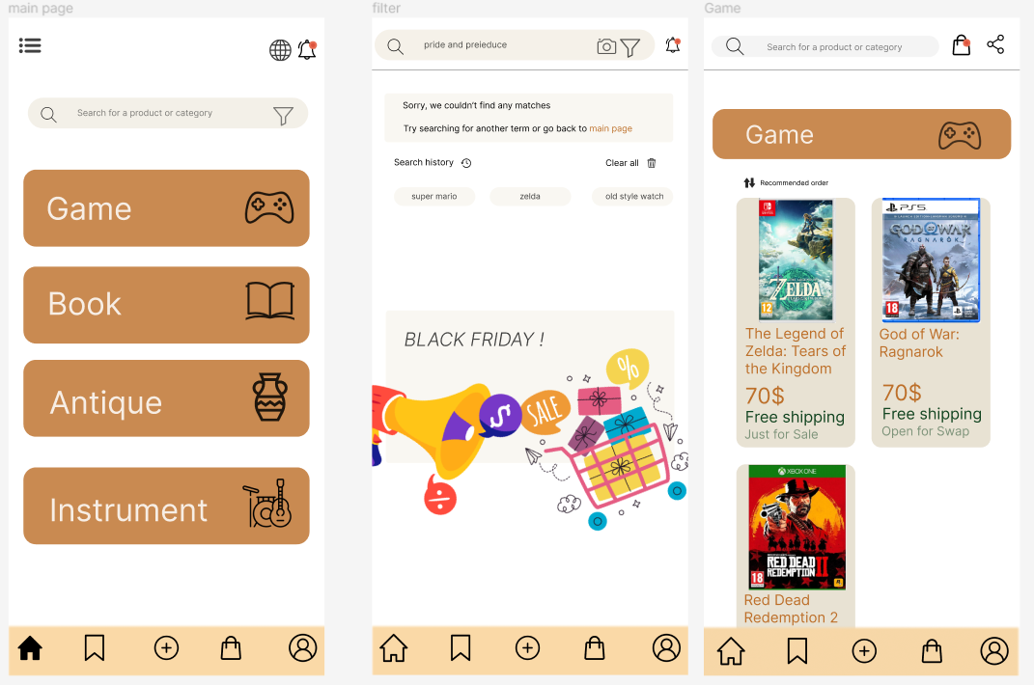

**metin, ekran görüntüsü, web sitesi, çevrimiçi reklamcılık içeren bir resim

Açıklama otomatik olarak oluşturuldu**

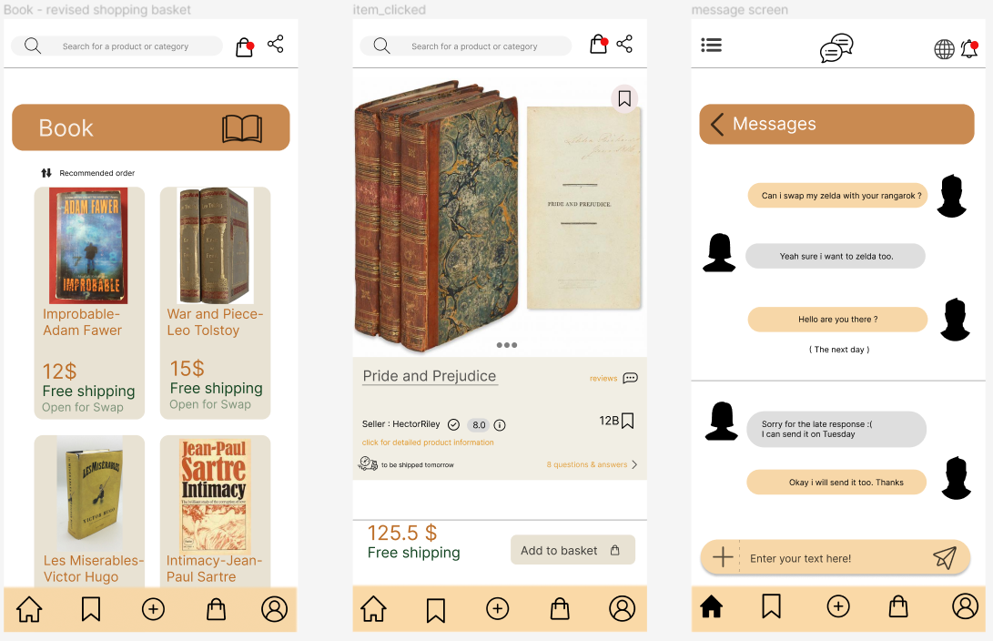

**metin, ekran görüntüsü, yazı tipi, sayı, numara içeren bir resim

Açıklama otomatik olarak oluşturuldu**

**metin, ekran görüntüsü, yazılım, yazı tipi içeren bir resim

Açıklama otomatik olarak oluşturuldu**

**6) Heuristic Evaluation :**

**1) Usability Problem: Inefficient Search and Filter (Nielsen's Heuristic: Consistency and standards)**

The search and filter function may not return accurate results due to improper tagging or lack of detailed filter options. This might lead to users spending excessive time searching for their desired item, leading to a poor user experience.

Fix: Implement a robust tagging and categorization system for listed items. Also, enhance the filter feature by providing more detailed and diverse filter options, such as item condition, location, price range, category, etc.

**2) Usability Problem: Poor Communication Channel (Nielsen’s Heuristic: Visibility of system status)**

If there is a delay or lack of responsiveness in the in-app chat function, users may feel frustrated and unsure whether their messages are being sent or received, affecting the overall transaction experience.

Fix: Make sure to include clear system feedback when a user sends a message (e.g., "message sent" confirmation). Consider implementing a real-time chat function, and always show the status of the message (e.g., sent, delivered, read).

**2.1) Usability Problem: Unclear Shopping Basket / Notification Status (Nielsen’s Heuristic: Visibility of system status)**

If users can only see a dot indicating items in their shopping basket / alarm- notification instead of a specific number, they won't have clear feedback on the status. This could lead to confusion and possibly cause errors, making the shopping process less efficient and user-friendly.

Fix: Always display the number of items in the shopping basket and notifications, updating the number this in real-time as items are added or removed. This way, users will have a clear understanding of their current shopping status.

**3) Usability Problem: Inadequate Review System (Nielsen's Heuristic: Flexibility and efficiency of use)**

If the review system does not allow users to leave detailed feedback, it can make it difficult for other users to make informed decisions about transactions. A lack of sufficient information in reviews can lead to hesitance or uncertainty when purchasing or selling items.

Fix: Enhance the review system by including specific item condition, seller communication, and delivery time. Encourage users to leave detailed reviews by providing text boxes where they can describe their experiences. This way, other users can benefit from comprehensive feedback to make better transaction decisions.

**4) Usability Problem: Lack of Confirmation Prompts and Prevention Measures (Nielsen's Heuristic: Error prevention)**

There is an instances in the app where users can perform significant actions, like finalizing a purchase, with a single tap. Without a confirmation prompt, users can easily make mistakes and potentially perform irreversible actions unintentionally, leading to frustration and dissatisfaction.

Fix: Incorporate confirmation dialogs or prompts before any significant action is executed in the app. For example, before users finalize a purchase, a confirmation prompt stating "Confirm Purchase?" can be displayed. Likewise, before deleting an item from the list, a prompt stating "Are you sure you want to delete this item?" can help prevent unintentional deletions. This proactive approach helps prevent user errors and enhances the overall user experience.

**5) Recognition Rather Than Recall (Nielsen's Heuristic)** - The app minimizes the user's memory load by making objects, actions, and options visible. For instance, when browsing through different categories, users can clearly see all available options, reducing the need for recall.

**6) Match between System and the Real World (Nielsen's Heuristic)** - The app speaks the users' language, using terms and phrases that are familiar to them. The sequence of actions follows real-world conventions, making the app intuitive and easy to use.

**7)User Control and Freedom (Nielsen's Heuristic)** - The app supports user autonomy and control. It provides 'undo' and 'redo' options and allows users to navigate freely without feeling trapped.

**8)Aesthetic and Minimalist Design (Nielsen's Heuristic)** - The app prioritizes simplicity in its design. It avoids unnecessary information that could potentially distract users and does not compromise the visibility of important features.

**9)Help Users Recognize, Diagnose, and Recover from Errors (Nielsen's Heuristic)** - The app effectively communicates errors and suggests solutions to users. The error messages are expressed in plain language, clearly stating the problem, and suggesting a constructive solution.

**10) Help and Documentation (Nielsen's Heuristic)** - The app provides helpful documentation to assist users in understanding how to use the app. This documentation is easy to search and provides step-by-step instructions for users to follow. It acts as a useful resource when users encounter issues or need clarification on how to use certain features. (we have an information button for this)

**7) revised screens according to usability problems**

**1) metin, ekran görüntüsü, yazı tipi, tasarım içeren bir resim

Açıklama otomatik olarak oluşturuldu**

**2)metin, ekran görüntüsü, yazı tipi, tasarım içeren bir resim

Açıklama otomatik olarak oluşturuldu**

**2.1)**

**metin, ekran görüntüsü, yazı tipi, çizgi içeren bir resim

Açıklama otomatik olarak oluşturuldu**

**metin, ekran görüntüsü, yazı tipi, logo içeren bir resim

Açıklama otomatik olarak oluşturuldu**

**3)metin, ekran görüntüsü, yazı tipi, sayı, numara içeren bir resim

Açıklama otomatik olarak oluşturuldu**

**4)**

**metin, ekran görüntüsü, web sitesi, web sayfası içeren bir resim

Açıklama otomatik olarak oluşturuldu**

**8) Appendix – all screens**

metin, ekran görüntüsü, tasarım, yazı tipi içeren bir resim

Açıklama otomatik olarak oluşturuldu

metin, ekran görüntüsü, yazılım, bilgisayar simgesi içeren bir resim

Açıklama otomatik olarak oluşturuldu

metin, ekran görüntüsü, web sitesi, web sayfası içeren bir resim

Açıklama otomatik olarak oluşturuldu

metin, ekran görüntüsü, kitap içeren bir resim

Açıklama otomatik olarak oluşturuldu

metin, ekran görüntüsü, yazı tipi, web sitesi içeren bir resim

Açıklama otomatik olarak oluşturuldu

metin, ekran görüntüsü, yazı tipi, sayı, numara içeren bir resim

Açıklama otomatik olarak oluşturuldu

metin, ekran görüntüsü, web sitesi, web sayfası içeren bir resim

Açıklama otomatik olarak oluşturuldu

We also have a dark mode :

metin, ekran görüntüsü içeren bir resim

Açıklama otomatik olarak oluşturuldu

metin, ekran görüntüsü, yazılım, bilgisayar simgesi içeren bir resim

Açıklama otomatik olarak oluşturuldu